Lab: SQLAlchemy
The following tasks do not require submissions to the Judge System.

Installation and Configuration
We are going to create our first SQLAlchemy project. SQLAlchemy simplifies the process of working with databases in Python by providing a set of tools and a more Pythonic way to manage and query our data. It is a powerful library for anyone who needs to work with databases in their Python applications.
To create the project, we will be using PyCharm Professional (you are free to use PyCharm Community as well) as our integrated development environment. Let us launch the tool and navigate to File -> New Project:
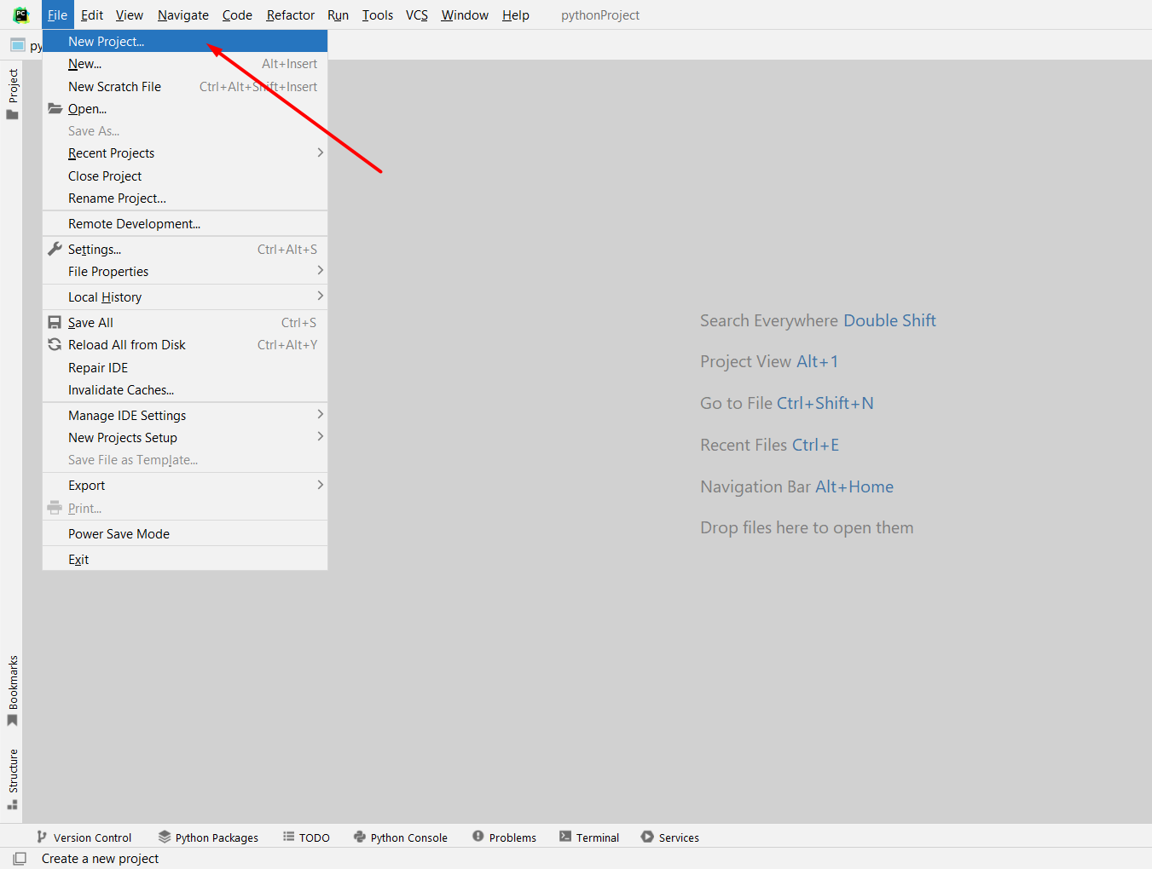
For this lab we will be using a simple Python project. Configure the project's location and name, ensuring the virtual environment is set up as well: 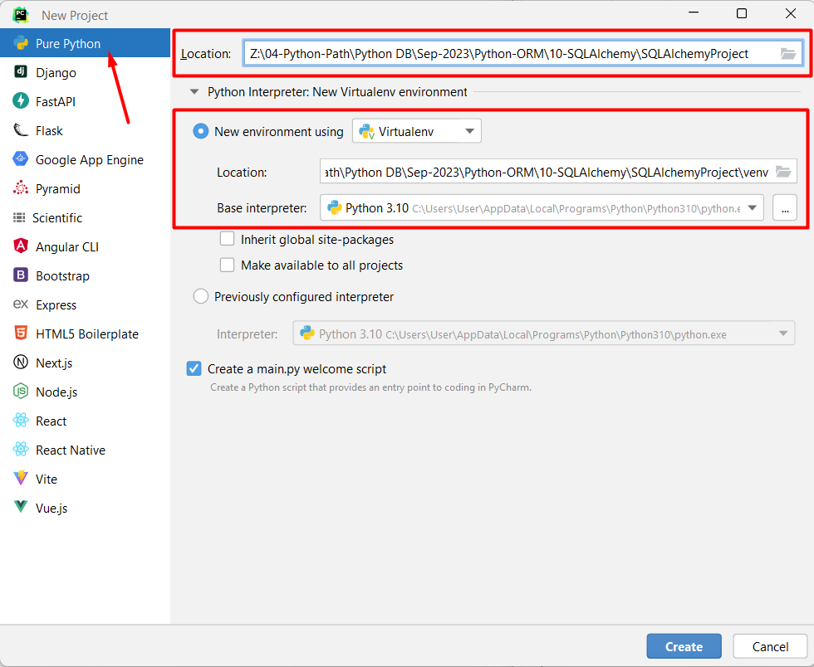
Click the "Create" button to initiate the project creation process: 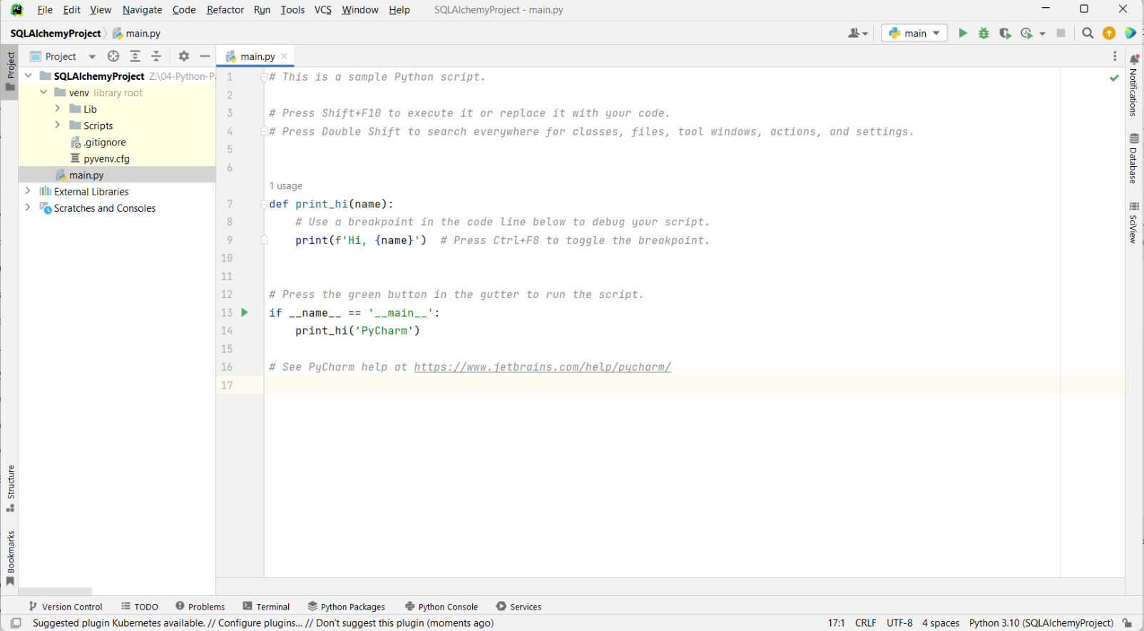
Next, let us make the needed installations:
- Install SQLAlchemy using the command "pip intsall sqlalchemy"
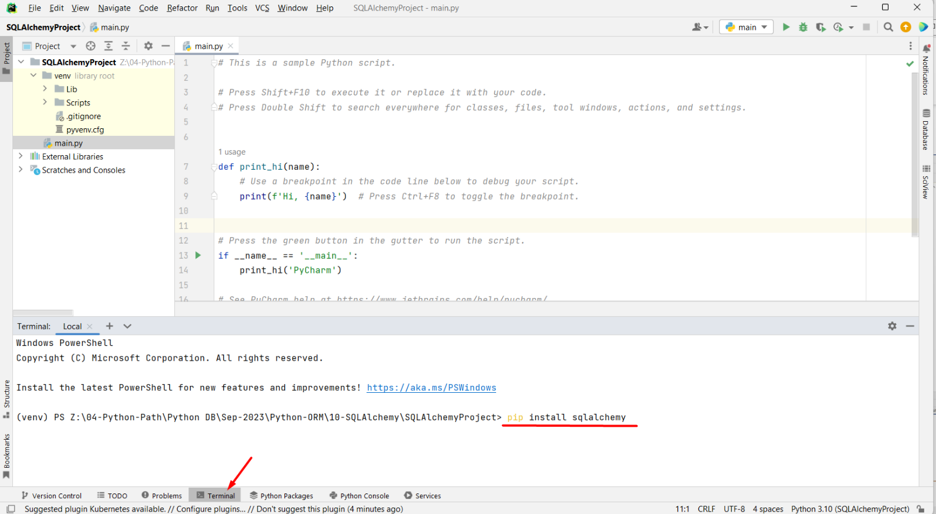
- Install the PostgreSQL driver (as we will be using PostgreSQL as our project database system) using the command "pip install psycopg2".
The main.py file we will use to import the required modules from the SQLAlchemy library in Python. The create_engine function is used to establish a connection to the database: 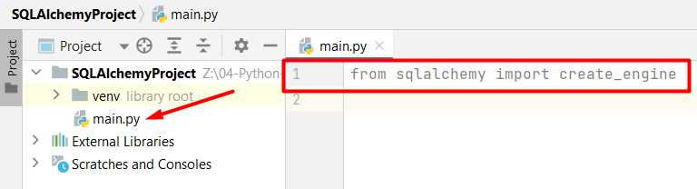
Now, let us use the create_engine function to establish the connection to the PostgreSQL database.
First, we will create a string variable (constant) called "DATABASE_URL" that holds the connection string for our PostgreSQL database:
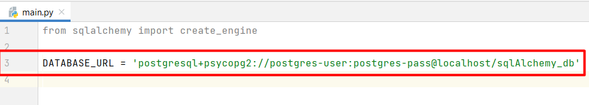
- "postgresql+psycopg2" specifies that we are connecting to PostgreSQL. SQLAlchemy uses this information to determine the appropriate driver or connector to use.
- "postgres-user" is the username used to authenticate with the PostgreSQL database.
- "postgres-pass" is the password used to access the database.
- "localhost" is the host where the PostgreSQL database is located. In this case, we want to use the local database on our machine.
- "sqlAlchemy_db" is the name of the specific database within the PostgreSQL server that we want to connect to. This is the database where our data is stored.
Next, we will call the create_engine function and pass the created variable as an argument to create the database engine:
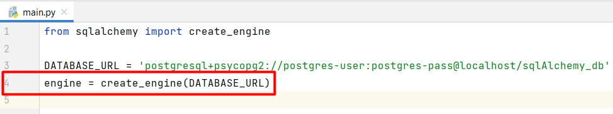

Defining Models
It is time to define our first model using SQLAlchemy's ORM. First, let us create a new Python file called models.py where we will store our models. In this file we will import the declarative_base function used to create a base class for defining the database tables as Python classes: 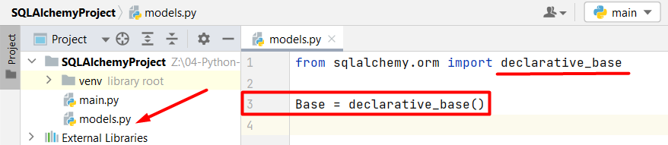
We will use the created "Base" class as a parent for our database table classes. It provides the necessary functionality for mapping our Python class to a database table.
Now, let us define a "User" table with three columns: "id", "username", and "email":
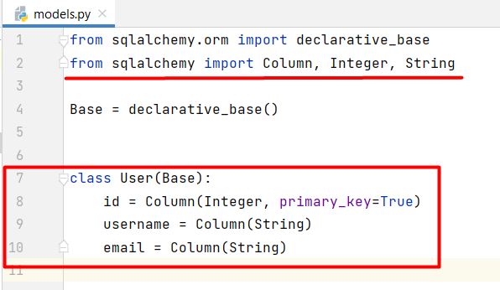
- We imported the classes and the types needed to define the columns of our database table.
- Then, we defined a Python class called "User", which represents a database table and inherits from the "Base" class.
- We added three columns to our table:
  - A primary key column named "id" with the data type "Integer" and set the "primary_key" argument to True.
  - A username column of data type "String".
  - An email column of data type "String".
Before we create the table, we want to specify the name of the database table as "users". We can do that by using the __tablename__ attribute:
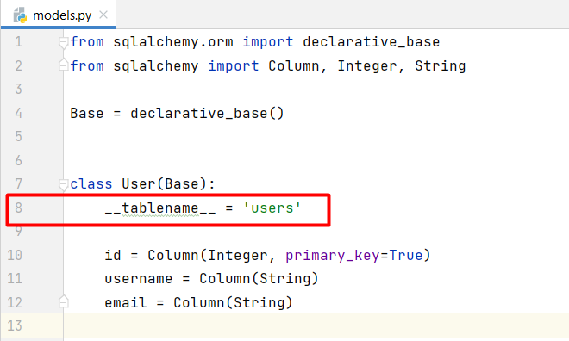
After defining the table schema as a Python class, we will use the create_all method to create the corresponding table in the database (Note, that the method is called only when no migration tool is going to be used). We are passing the "engine" object (previously created with the database connection details) to the method. This action actually generates the SQL statements needed to create the "users" table in the database and executes them. This is a manual approach for creating tables in the database and is not convenient if we need to make some changes to the models, respectively to tables later:
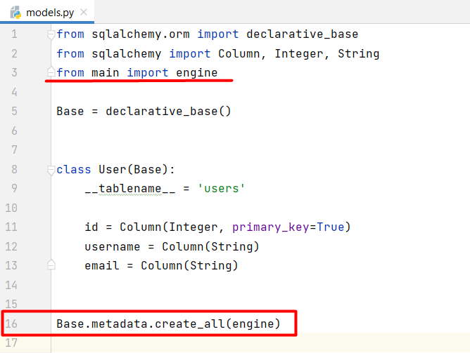
Finally, we can run the models.py file and see the changes to our database:
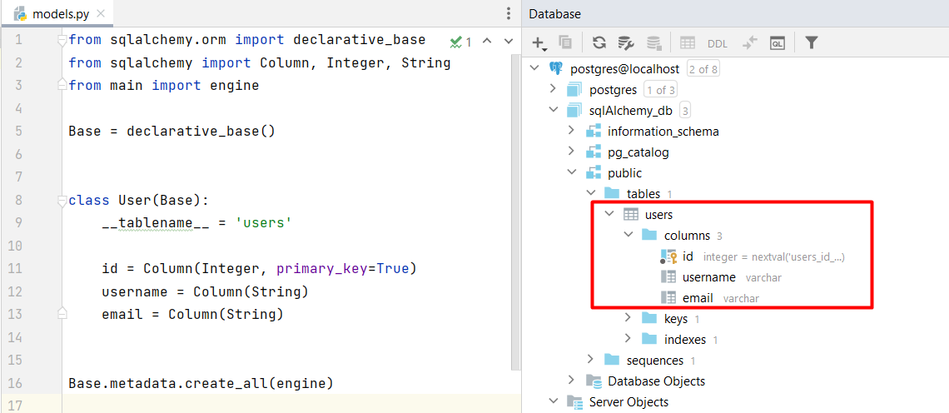

Migrations

3.1 Install and Configure Alembic
As our application evolves, we may need to make changes to our database schema. These changes can include adding or modifying tables, columns, indexes, and relationships. Alembic provides a structured way to define these changes in Python code and apply them to the database, ensuring consistency across different database instances (e.g., development, staging, production).
Let us install the Alembic package in Python using the command "pip install alembic":
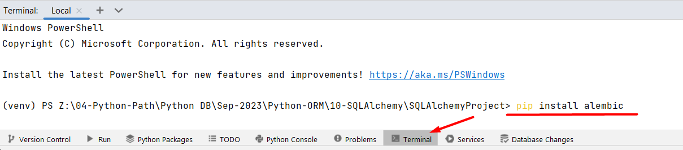
However, we need to initialize an Alembic migration environment for our project. Let us type down the command "alembic init alembic":
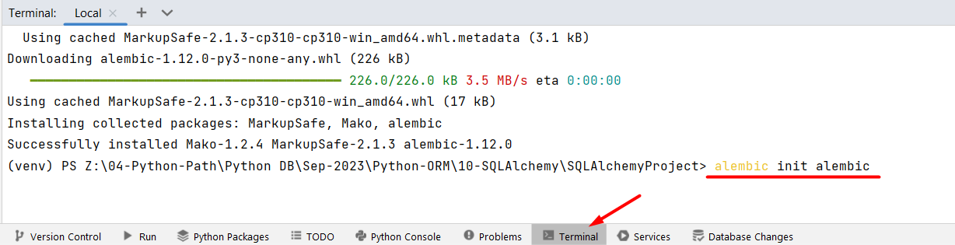
This way Alembic will create a directory named "alembic" in our project's root directory. Inside this directory, Alembic will create several subdirectories and files, including a versions directory for storing migration scripts, a script.py.mako template file for creating new migrations, and an alembic.ini configuration file:
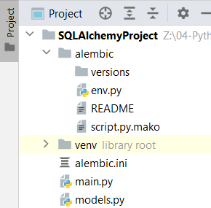
The alembic.ini file is an important configuration file where we will specify details about our database connection, which will allow Alembic to connect to our database and apply migrations. Let us open the file and find the sqlalchemy.url configuration setting. We will change the connection string to the one we use for this project:
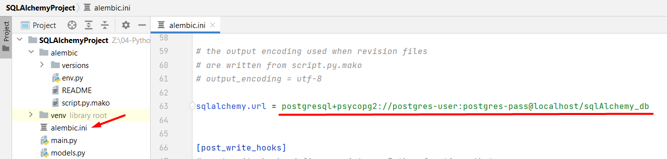
The env.py file serves as the configuration and entry point for managing database migrations in a Python project. In this file, we will specify the database schema that Alembic should compare against when generating database migration scripts. We will set the target_metadata variable to the metadata attribute of the Base class:
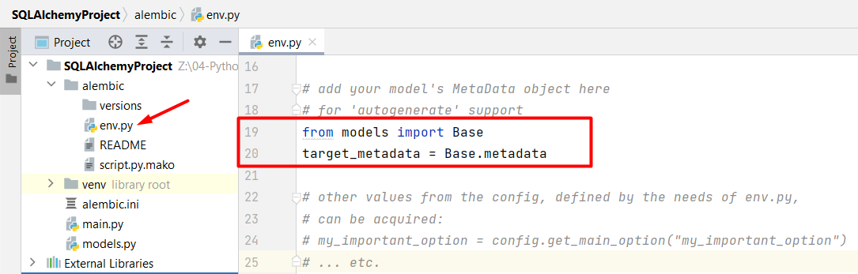

3.2 Using Alembic
Now, it is time to create a migration and apply it to the database. First, let us generate a new migration script in Alembic with the terminal command "alembic revision --autogenerate -m "Add User Table":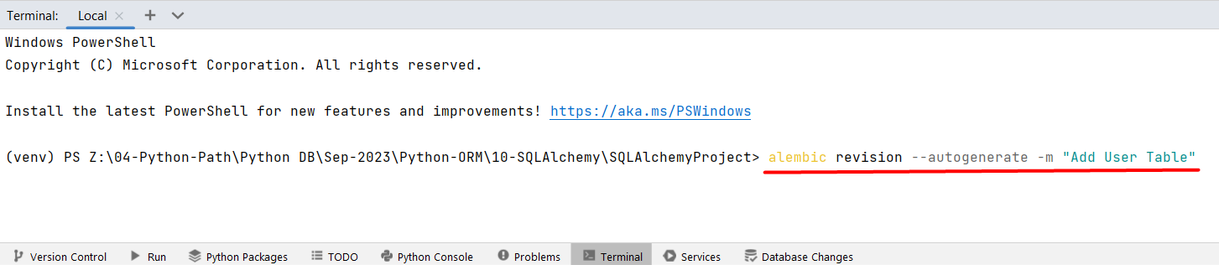
Here is a breakdown of what this command does:
- "alembic revision" - the Alembic command for creating a new migration revision.
- "--autogenerate" - the flag that tells Alembic to automatically generate the migration script by comparing the current state of the database to the state defined in our SQLAlchemy models.
- "-m "Add User Table" - the flag is used to provide a message for the migration.
When the migration script is successfully generated, it will appear in the versions directory:
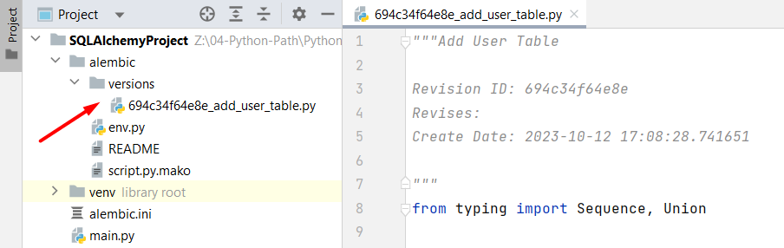
Next, let us apply the pending migration with the terminal command "alembic upgrade head":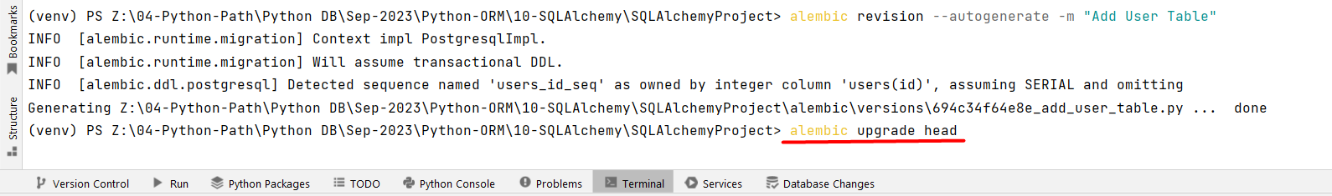
Here is a breakdown of what this command does:
- "alembic upgrade" - the Alembic command used to apply database migrations.
- "head" - the keyword represents the latest available version of the database schema. This way we are telling Alembic to apply all pending migrations up to the latest version of the database schema.
Now, we can see two tables in our database:
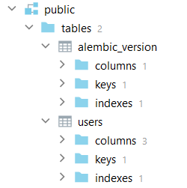
The "alembic_version" table is a system table that Alembic automatically creates and uses to keep track of the current migration version of our database. It is an essential part of Alembic's functionality for managing migrations. The table typically contains a single row with a version identifier.

Queries and CRUD Operations

4.1. Creating a Session
When working with SQLAlchemy to create queries, it is crucial to establish a session. A session in SQLAlchemy is a critical component for managing interactions with the database. It helps to ensure that your queries are executed consistently and efficiently while providing a structured and controlled way to work with the database. Let us create a Session class in SQLAlchemy:
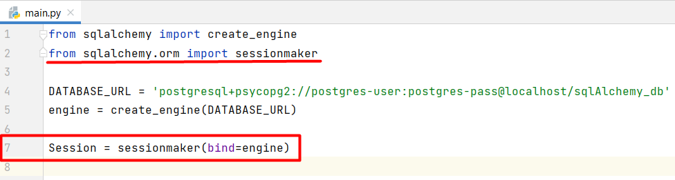
- The sessionmaker class is a factory for creating SQLAlchemy sessions.
- By binding the sessionmaker to the engine, we associate the session with the sqlAlchemy_db database, so any operations performed through this session will be executed on that database.
- The Session class we created is essentially a session factory. You will use it to create individual sessions whenever we need to work with the database.

4.2. Perform Database Operations
Let us start by creating a new Python file called "services" where we will put queries and interactions with the database. Here we will write functions to perform various database operations. First, we will import the "User" model and the "Session" factory class: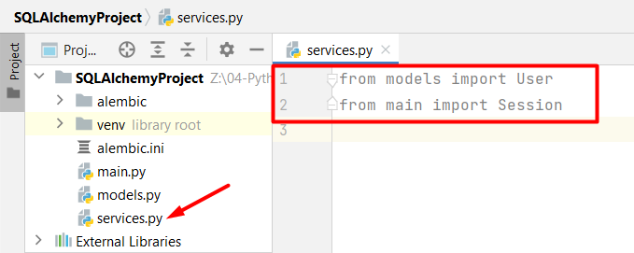
Now, we will create a new session, create a new user object, add it to that session, and then commit the changes to the database:
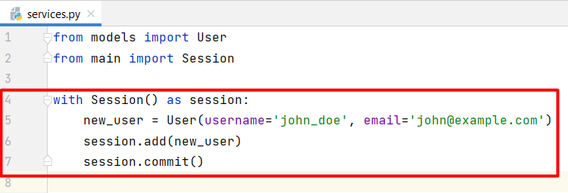
Run the services.py file to execute the code. If we open the database table, we can see the changes: 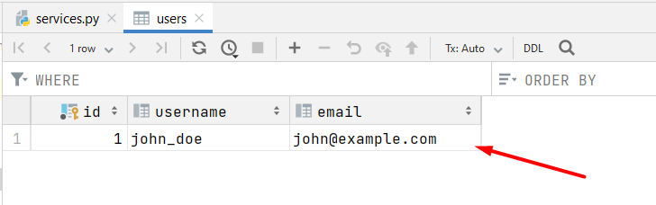
To retrieve all data from a table, we simply need to use the all() method on a query that is constructed using the query() method. The query() method is used to create a query that specifies which records we want to retrieve, and when we apply the all() method to that query, it fetches all the records matching our query criteria from the database:
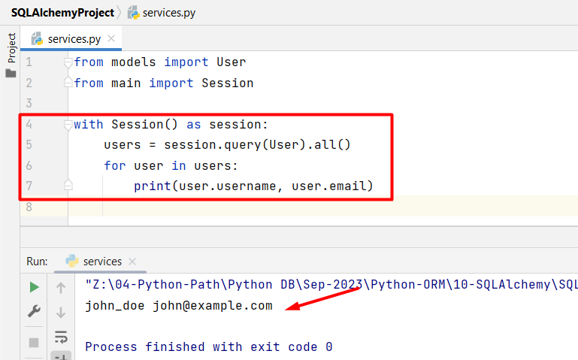
To update a record from the database, first, we will need to get the object that we want to update. To get a user object in SQLAlchemy we can use the filter_by() method to filter the records based on the username "john_doe" and then use first() method to retrieve the first matching record. It retrieves the first matching user, or it returns None:
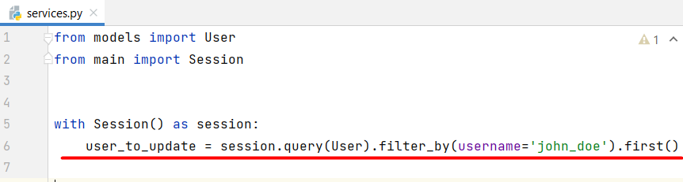
If the user object is found, we will assign the new email address to the email attribute of the user_to_update object:
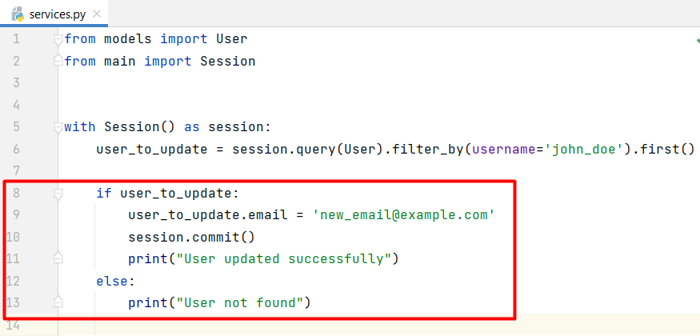
We can check the updated data in the database table: 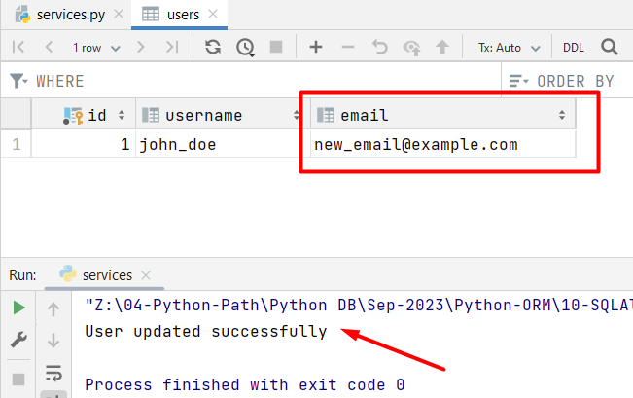
Similar, to the process of updating, we will execute a deletion using SQLAlchemy. First, we need to get the User object we want to delete. Then, if the object is found, we will use the delete() method on the found object. It does not immediately remove the record from the database but flags it for deletion within the current session. The actual deletion of the record from the database occurs when we commit the changes using the session.commit() command:
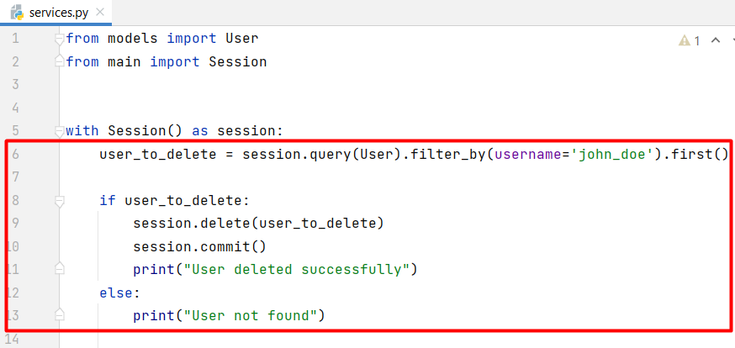
We can check the changes made to the database table: 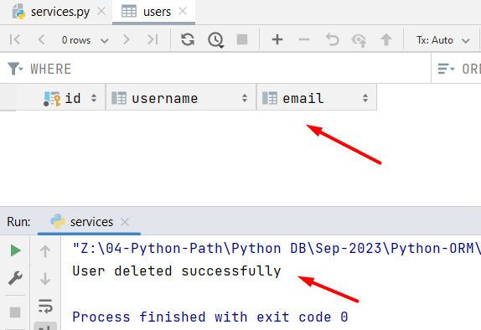

Transactions
For this example, we will need to populate the "users" table with some data. Hint: use the add_all() method:
username | email
john_doe | john.doe@example.com
sarah_smith | sarah.smith@gmail.com
mike_jones | mike.jones@company.com
emma_wilson | emma.wilson@domain.net
david_brown | david.brown@email.org
Now, let us write our first transaction. Transactions are often used to group multiple database operations into a single unit of work, ensuring that all changes are committed together or rolled back in case of an error.
First, we will create a new session. Then, we will create try-except-finally blocks to frame the transaction:
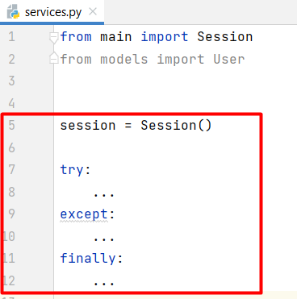
In the try block, we will start a transaction within the session. All the subsequent operations will be part of this transaction. Then, we will construct a query to delete all records from the "User" table. It is executed within the transaction:
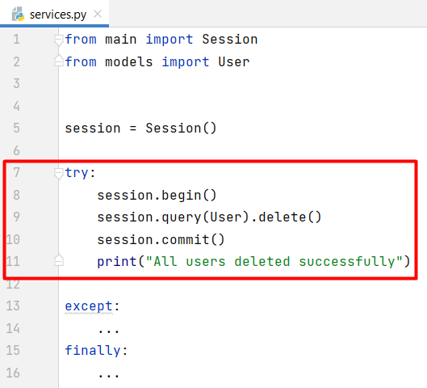
In the except block, if an Exception occurs during the execution of the transaction, the rollback() method is called to roll back the transaction (any changes made within the transaction are undone) and the error message along with the details will be printed:
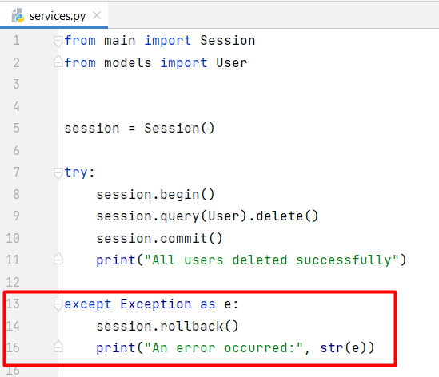
The finally block is executed whether the try block completes successfully or an exception occurs. In it, the session is closed to release any resources and ensure proper cleanup:
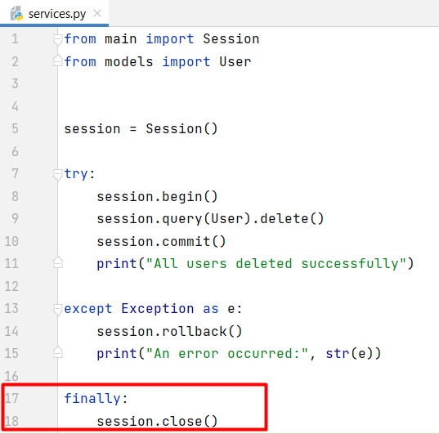

Simple Relations

6.1. Defining a Relation
Let us create a new model called "Order" that establishes a many-to-one relationship with the "User" model. First, let us create the model with the main fields: "id" (Primary key field) and "is_completed" (Boolean field with a default value set to False):
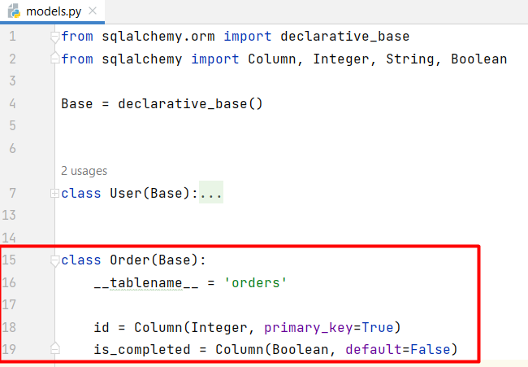
Next, we will establish a many-to-one relationship between the "Order" model and the "User" model. We will use a "user_id" column to store the foreign key, which is an efficient way to link orders to users. Then, we will add a "user" relationship to specify the relation between the orders and the users. It does not add a column to the "orders" table, but we use it to access the associated "User" object:
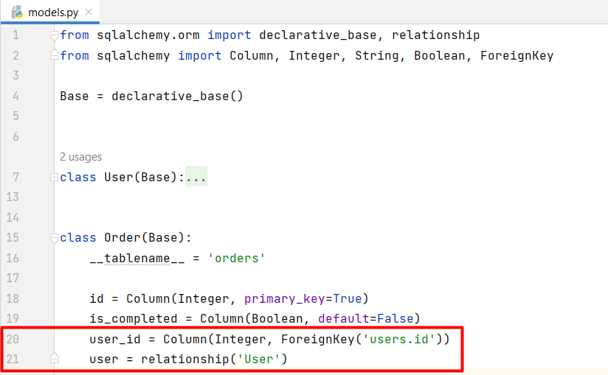
Let us check the resulting table in the database:
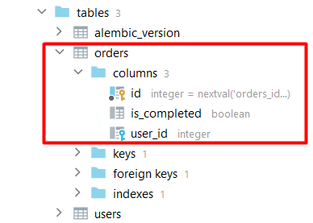

6.2. Populate Order Table
Let us populate the "Order" table. First, we will need to populate the "User" table - we will use the same data as at the 5th bullet point above:
username | email
john_doe | john.doe@example.com
sarah_smith | sarah.smith@gmail.com
mike_jones | mike.jones@company.com
emma_wilson | emma.wilson@domain.net
david_brown | david.brown@email.org
Since we have added and deleted data multiple times, the user IDs may not begin from lower numbers like 1, 2, or 3; instead, they might start from values such as 7, or 8. We can check the IDs explicitly, so we do not hit an error:
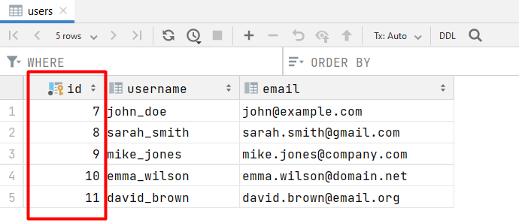
This time we will add multiple data to the "orders" table. For that, we will use the add_all() method. In the orders table, there are 3 columns - the "id" column is automatically populated as it is a primary key, and the "is_completed" column has a default value; so we only need to explicitly set the "user_id" values:
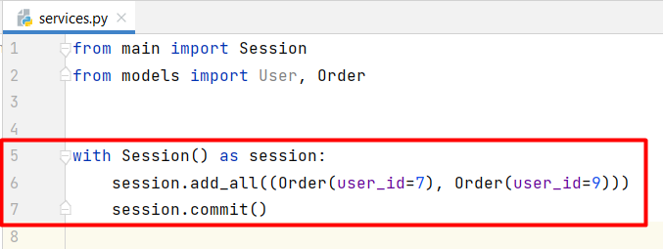
Let us execute the query and check the orders database table:
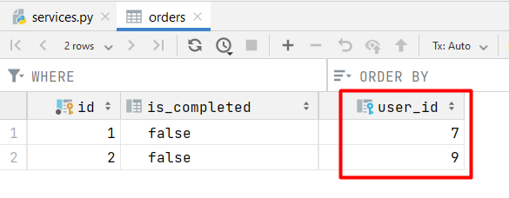

6.3. Queries for Relationships
Let us retrieve data from the "orders" table and visualize it in a user-friendly way. We want to retrieve all orders, sort them in descending order by "user_id" and return information about the order ID, whether is it completed, and the username of the user related to that order in the format:
"Order number {order.id}, Is completed: {order.is_completed}, Username: {user.username}"
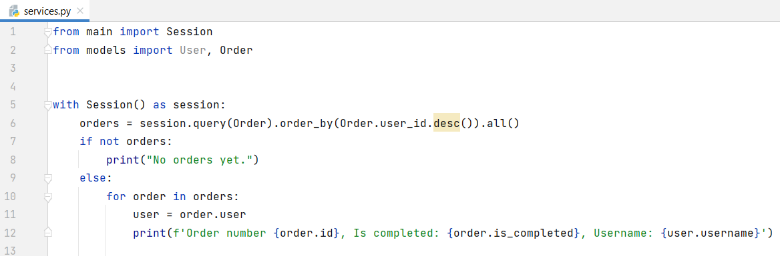

Database Pooling
A connection pool improves the efficiency and performance of database interactions by maintaining a set of connections that can be shared and reused, rather than creating new connections for each request or operation. This is particularly valuable in scenarios where multiple users or threads need to access the database concurrently, as it helps manage resources and reduces the overhead associated with connection management.
Let us configure a database connection pool with an initial size of 10 connections and the ability to create up to 20 additional connections temporarily if needed:
